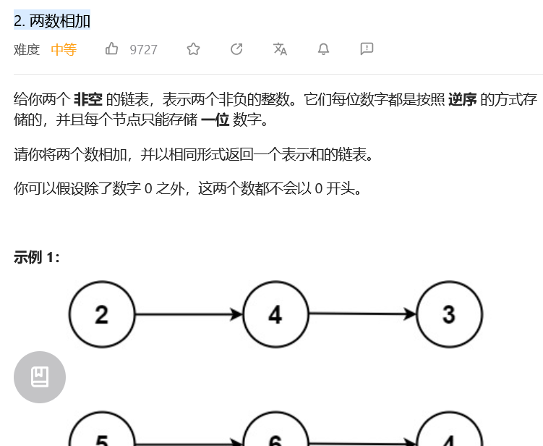
# Definition for singly-linked list.
# class ListNode:
# def __init__(self, val=0, next=None):
# self.val = val
# self.next = next
class Solution:
def addTwoNumbers(self, l1: ListNode, l2: ListNode) -> ListNode:
dummy = ListNode(0) # 哑节点
current = dummy # 当前节点
carry = 0 # 进位

while l1 or l2:
# 获取l1和l2的值，如果链表已经遍历完，则值为0
x = l1.val if l1 else 0
y = l2.val if l2 else 0

# 将l1和l2的值以及进位相加
sum = x + y + carry

# 更新进位
carry = sum // 10

# 创建新节点，并将个位数作为节点的值
current.next = ListNode(sum % 10)

# 更新指针
current = current.next
if l1:
l1 = l1.next
if l2:
l2 = l2.next

# 如果最后一位相加后产生了进位，需要添加新节点
if carry > 0:
current.next = ListNode(carry)

return dummy.next

